Creating accessible tables in Canvas

Canvas includes some options to improve the accessibility of tables. Read the following guide to learn how to add Cell Headers and add a Caption.

Note: Tables should only be used for tabular data. They should not be used to layout and align general page content.

First, add a table

- In the Canvas Rich Content Editor (RCE) select the Table icon then Table, and select the cells to create a table of the appropriate size.
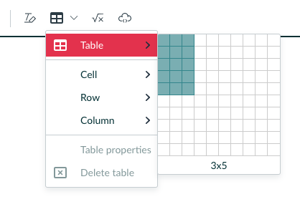
- Use the buttons below the table to add additional columns or rows if required.
- Next add the relevant data to the table.

Identify the header cells

- Select the header cells which identify the type of information in the relevant table row or column, then select the Table icon again. Choose Cell > Cell properties.
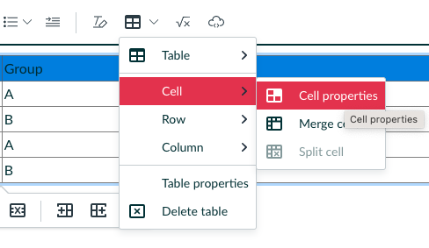
- Set the Cell type to Header cell.
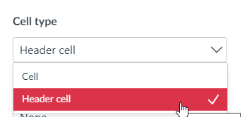
- Set the Scope.
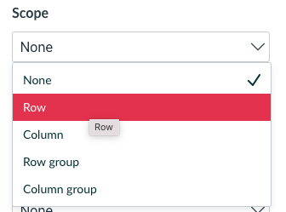

  - If the cell is the header for a column, select Column.
  - If the cell is the header for a row, select Row.
  - If there are merged cells in your table and the cell is the header for several columns or rows, use the Row group or Column group settings.
- Save.

Add a caption

- With your cursor inside the table, select the Table icon again and choose Table properties.
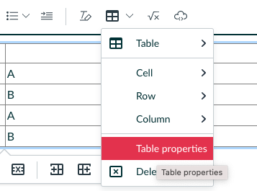
- Check the box for Show caption and Save.
- Space should now appear above the table where you can type a caption.
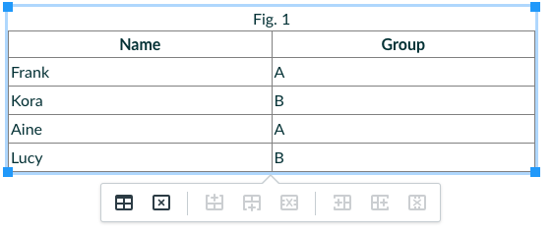

For further guidance on creating tables within Canvas please see How do I insert a a table using the Rich Content Editor.

